  Tuesday/Thursday 11:30-12:50

Klinger comments: This is very well done. Here’s what makes it so good:

* It goes beyond the minimum of what was asked for
* It doesn’t rely on opinion, it gives facts. There’s data here on how much they sell and the number of stores.
* The data and other facts make it interesting. One learns from reading this.
* The market segments are clearly defined and then for each segment there is a distinct marketing mix.
* For each element of the marketing mix, there is a statement about why that element is suited to that segment.
* The marketing mix is specific.

Homework #5

UGG Boots

December 14, 2017

Sakshi Kulshrestha, Tetyana Gorbach, Cody Tindle, Tony Hartmann

1)Identify the product line

1)UGG Boots



**HISTORY**

UGG was founded in California in 1978 by Australian surfers Brian Smith and Doug Jensen.  The term, “ugg boots” originated from Australia, initially for utilitarian footwear worn for warmth, and which were often worn by surfers during the 1960s. In their first season in business, Ugg Imports sold 28 pairs of boots. Due to other business commitments, in 1979 Jensen handed over his share of the company to Smith. Sales steadily grew and Smith set up Ugg Holdings Inc. and in 1985 registered a US trademark on a rams head logo with the words "Original UGG Boot UGG Australia". By 1994, 80 percent of UGGs sales were in southern [Orange County](https://en.wikipedia.org/wiki/Orange_County,_California), but the company gained international attention after the boots were worn by the U.S. Olympic team in Lillehammer for the [1994 Winter Olympics](https://en.wikipedia.org/wiki/1994_Winter_Olympics).

In 1995, [Deckers Brands](https://en.wikipedia.org/wiki/Deckers_Outdoor_Corporation) (footwear designer), acquired Smith's business for $14.6 million and continued to expand it. During the late 1990s, UGG began experiencing double-digit sales growth as Deckers developed the company into an international brand. In 2003, UGG boots were included on Oprah Winfrey show as part of "Oprah’s Favorite Things." Afterwards, the brand received an unprecedented surge in sales. In 2006, UGG opened its first brick and mortar store in New York's [SoHo](https://en.wikipedia.org/wiki/SoHo,_Manhattan) neighborhood. The company opened its first international store in Japan later that same year. UGG boots have been a style staple since they first appeared on the [Oprah Winfrey](https://en.wikipedia.org/wiki/Oprah_Winfrey) show in her second edition of "[Oprah's Favorite Things](https://en.wikipedia.org/wiki/Oprah%27s_Favorite_Things)" in 2003, in which she purchased over 350 shoes for her staff and audience. The boots gained a large celebrity following and were frequently seen on notable people such as [Kate Upton](https://en.wikipedia.org/wiki/Kate_Upton), [Blake Lively](https://en.wikipedia.org/wiki/Blake_Lively), [Cameron Diaz](https://en.wikipedia.org/wiki/Cameron_Diaz), and [Sarah Jessica Parker](https://en.wikipedia.org/wiki/Sarah_Jessica_Parker) who also wore them on the HBO series "Sex and the City" as [Carrie Bradshaw](https://en.wikipedia.org/wiki/Carrie_Bradshaw).

**MARKET SHARE AND TARGET MARKET**

UGG’s marketing campaign by famous celebrities led to an exponential growth in the brand's popularity and recognizability. The company’s profits have consistently increased over the years, with sales exceeding $1 billion consecutively since 2011. Ugg sales account for about 93% of Deckers' revenue. UGG’s business is largely driven by the US market, where the company does 70% of its sales. It delivers more than $1 billion in annual sales, and partners with the best retailers globally and owns over 130 concept and outlet stores worldwide in key markets including New York, San Francisco, Los Angeles, Paris, London, Tokyo, Shanghai and Beijing.

UGG’s target market is young to middle aged people, both male and female, who are in the higher middle or upper class. It targets its products towards people who live a luxurious and a fashionable life. Their target market is around people who want to look fashionable and feel comfortable during everyday life. The high quality sheepskin UGG uses to make their products makes their boots comfortable and wearable every day. Their products are sold at high prices which means they are targeted towards people who are in the right financial position to afford them. UGG boots are available in both pull-on and lace-up varieties and their height can range from just above the ankle to above the knee.Some variations of Ugg style boots have also been made from kangaroo fur and leather. There are also synthetic boots. They have created different types of footwear, from sandals and slippers to boots. They also come in different colors, so customers can get different colors to match any outfit. We thought UGG boots would be a good choice for this assignment since it offers such a great variety and creates boots for kids, women, and men.

2)Identify the market research you would do to understand the target market. Include the reason for the research and what actions you might take based upon the result.

**UGG MARKET RESEARCH**

It is not difficult to determine the UGG boots’ target geographics, because it is obvious that the location is in the places with cold climate. However, there are other characteristics of the target market that must be obtained through the market research.

* One of the ways to conduct a market research of the UGG boots is to partner up with ski resorts/skiing companies that would gather the information about their customers and provide it to UGG company for a certain payment. The market research will be done in the following way: when many people rent the skis, they change their normal boots to ski boots, and while they are standing in the line to rent the ski boots, the ski resort worker takes their personal information and at the same time the information about what boots you are wearing. The ski resort obtain information about their customers residence, age, gender, body measurements, and sometimes even the relationship status. The information of people that wear UGG boots will be taken and studied, which will determine the age, location, relationship status, gender and body measurements of the target market.
* As for the babies, the market research can be done by partnering with kindergarteners. They obtain records of children’s gender, ethnicity and family. The kindergarten teachers usually see what the children are wearing; therefore, they will be able to find out who bought the UGG boots, and the children’s information will be sent to better understand the target market. Specifically, the research will help to determine the ethnicity, age, gender and family information of their target market.
* Based upon both of the results that we obtain from above, we will analyze and see who are the biggest consumers inside our target market- is it men, women, or kids. For example, women are the biggest consumers that wear UGG boots in our target market, and men are the smallest. Therefore, going from there, we will decrease the investment that we are putting into attracting women consumers who already purchase our boots and try to invest money into reaching potential male consumers (by either doing more advertising, celebrity endorsements etc.) who purchase our product the least.

3) Identify the different segments in the market. Be specific about the characteristics of the segments. How does each element of the marketing mix address the target market segments?  Be specific! For example, how does the distribution of the product address the characteristics of each segment you identify in #2? Be specific, tell where ads are placed (which shows?), what prices are, etc.

**UGG Boots Segmentation and Marketing Mix**

**Market Segment 1)**: For parents with incomes between $70K and $120K that

have infants between the ages of 9 to18 months that are just beginning to walk

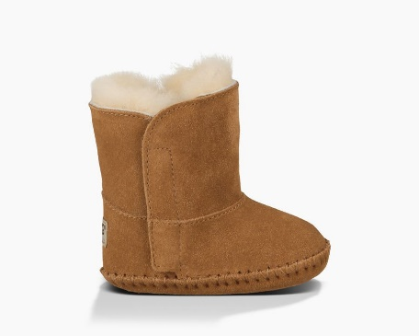

Product: UGG Caden

This tiny version of UGG’s Classic boot is made from soft suede lined with plush sheepskin to keep tiny toes toasty, while the sole offers some traction for a baby’s first steps.

Price: This ranges from anywhere between $40 to $60 depending on the shoe size

as well as the color. It is quite pricey because of the fact that  UGG targets parents in the higher middle or the upper class who can afford to buy these boots for their pre-walkers. This is also aimed at a financially upper class due to the fact that people with lower incomes do not usually buy any footwear for their babies that are just learning how to walk.

Promotion: This product is heavily marketed not towards the babies, but towards

the parents who think they need to provide their infants with supportive boots to help them with their walking. Hence, UGG can attract parents with the help of popular parenting websites like cradle.com, babble.com, babycenter.com, mamapedia. They can also market it through TV channels like Sprout, Parent TV and popular parenting magazines like Parents, American Baby, Baby Talk.

Distribution: The product is perfect to be distributed and sold at various stores as

well as online websites that parents usually visit when planning to buy baby gear and other baby related stuff. Some stores where this product can be distributed are like ToysRUs, Buy Buy Baby, BabiesRUs, Fisher-Price. It can also be distributed online via websites like Baby Swag and 4Moms.

**Market Segment 2)**: For parents with incomes between $70K and $120K that have baby girls between the ages of 6 and 10 years that adore pink color

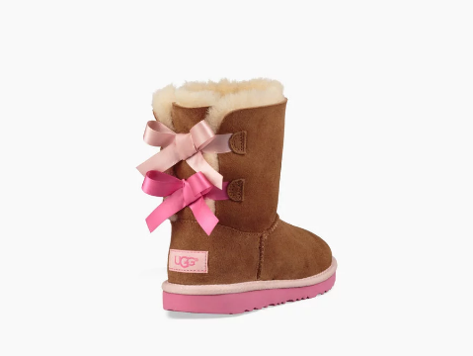

Product: UGG Bailey Bow

This boot is crafted with plush sheepskin, sweet bows up the back, and is built to move the way kids do. Each boot features a rocker-bottom shape for a barefoot feel and our super-lightweight outsole for traction and durability. It's also pretreated to protect against water and staining, so the little one can get into anything. Appealing to young girls because of the color and the bow design.

Price: Ranging from anywhere between a $100 to $150. Again, this is

comparatively more expensive than other brands that sell boots but as mentioned before, UGG targets a very niche population that can afford this kind of luxury.

Promotion: Since this product is for little girls, it can be advertised on TV channels

like Disney, and Nickelodeon. Similarly, it can be promoted by their favorite cartoon characters like the Powerpuff girls, Little Pony and Friends, and Dora The Explorer. The idea behind this is that even though the kids would not buy the product themselves, they will get attracted towards it and ask their parents to buy it for them. For targeting parents, the product can be promoted through ParentChannel.tv, or magazines like Today’s Parents.

Distribution: Stores like Nordstrom, Macy’s, Sears, Walmart, Target would be good

for distribution of this specific product because these stores sell a variety of products and very young girls are more likely to do most of their shopping with their parents that also often visit these stores for purchasing their clothing.

**Market Segment 3)**: For single, young women between ages 16 and 26 with incomes between $60K and $200K and having a high-end fashion sense

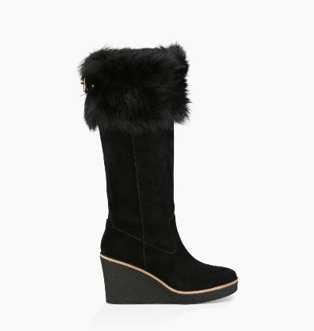

Product: UGG Valberg

These gorgeous suede boots feature a sheepskin cuff - adding a soft touch of heritage to any cold-weather look. Appeals to young females because of the wedges-like (another type of footwear) style this boot provides, and also the fur makes it look more luxurious.

Price: Ranges from anywhere between $250- $350. Not many people will be

willing to pay a price this high for a pair of boots but then some people do believe that “Price is a proxy for Quality!” and the brand uses real animal fur to create these boots so the quality has to be better than just any normal boots.

Promotion: This product can be successfully promoted through magazines that

most young girls read like Teen Vogue, Seventeen, Cosmopolitan, and Girl’s Life. It can also be advertised on TV shows that are extremely popular among girls like Pretty Little Liars, and the Vampire Diaries. The product can also be promoted through QVC that some women tend to watch.

Distribution: Due to the fact that this is a high-end product, it would be fitting to

distribute it in top notch stores like Forever 21, Zara, Hollister, and American Eagle which even though they are extremely costly, are still highly preferred by teen girls and young women in their 20s.

**Market Segment 4)**: For men between 25 to 35 years of age with incomes ranging

from $100K to $250K that like wearing sturdy, and durable footwear

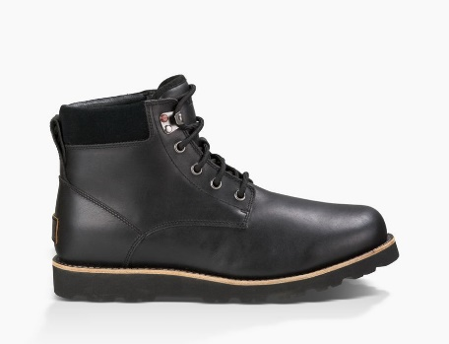

Product: UGG Seton TL

This waterproof leather boot features sealed seams, a natural wool interior, and traction-enhancing outsole. Appeals to young men because of its tough and handsome appearance.

Price: Ranging from $180-$220 based upon the size as well as the color of the

boots. Men in the upper middle or higher class would be willing to pay this amount for high quality boots made from real leather and fur.

Promotion: The product can be promoted through popular men’s fashion

magazines like Playboy, Esquire, Men’s Journal, GQ, Fantastic Man. It can be further promoted on men’s favorite tv shows like Game of thrones, The Walking Dead (Tv channel: AMC), The Americans (FX), Brooklyn Nine-Nine (Fox). Even though, this product is not a sporty one, we can also attract potential male consumers by advertising on ESPN, and ABC Sports.

Distribution: Based upon the price of this product, it would be a good fit for the top and

expensive stores where men earning more than 100K would be willing to buy it from like Giorgio Armani, Gucci, Salvatore Ferragamo, Burberry, and Louis Vuitton.

Works Cited

Ruiz, Nicola. “Ten Best Clothing Stores For Men.” *Forbes*, Forbes Magazine, 12 July 2012,

[www.forbes.com/2008/04/30/mens-clothing-stores-forbeslife-cx_nr_0430style.html#4e3322bbe54a](http://www.forbes.com/2008/04/30/mens-clothing-stores-forbeslife-cx_nr_0430style.html#4e3322bbe54a).

Schlossberg, Mallory. “Teen Shopping Survey.” *Business Insider*, Business Insider, 3 July 2016, [www.businessinsider.com/teen-shopping-survey-2016-6](http://www.businessinsider.com/teen-shopping-survey-2016-6).

“The Best Men's Fashion Magazines.” *Ranker*, www.ranker.com/list/the-best-men-and-_39_s-fashion-magazines/ranker-books.

“The Best Parenting Websites.” *Real Simple*, [www.realsimple.com/work-life/family/kids-parenting/best-parenting-websites](http://www.realsimple.com/work-life/family/kids-parenting/best-parenting-websites)*.*

*UGG® Official | Boots, Slippers & Shoes | Free Shipping & Returns*, www.ugg.com/.