Business Writing – Practical Basics
W.J. Klinger

Creating Tables for Comparisons
- You want people to be able to look at a table and immediately get your message
  - What is your message? Is one choice better than another? Are they all the same?
  - Can you see the message without reading the words in the table – that’s the best, if possible
  - Put thought into the different ways you might do a graph
- Tables should have headings for each of the columns and each row
- Do not put too much information in a row/cell. If it gets long, break it into smaller pieces
- If the item you are comparing is present or not, then use a simple check mark, X, or other symbol to show if it is present. Leave it blank, if it is not there.
- Sometimes you need to put in a number, such as number of vacation days. Then put in the number.
- Avoid, at all costs, putting lots of words or sentences in a table

Examples of Comparisons Using Charts
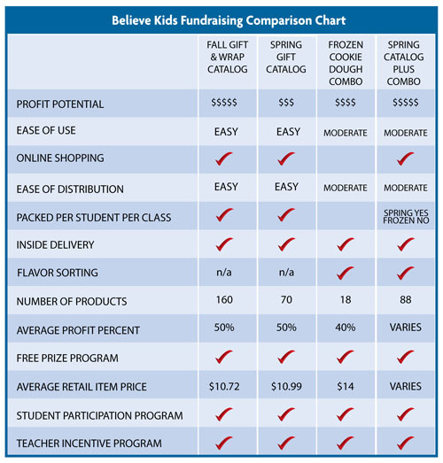
http://www.believekids.com/Images/fundraising_comparison_chart.jpg
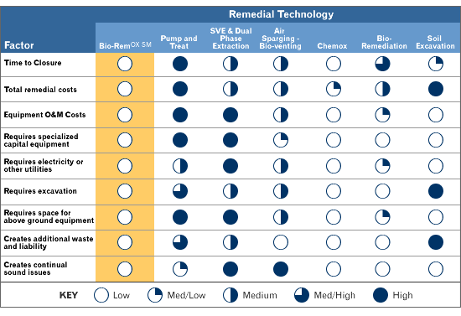
http://www.lessard-environmental.com/biorem/BioRemComparison.html
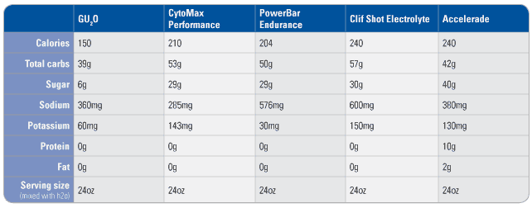
http://www.guenergy.com/images/comparison_chart2.gif
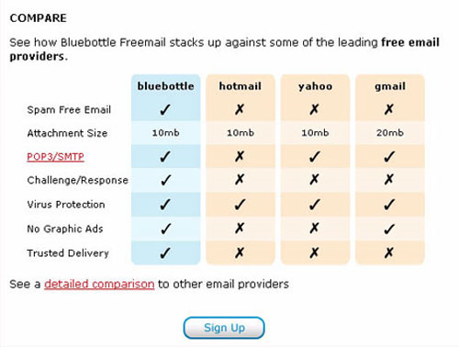
http://www.boxesandarrows.com/files/banda/getting-a-forms67/Image3.jpg
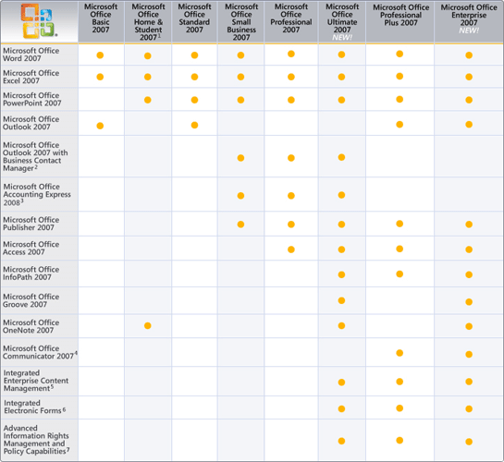
http://www.microsoft.com/australia/business/business-and-industry/images/pp_office_comparison.gif

